Day of Week Extraction

Definition
# Source: AI Source: Provided by: [Data Path: Persons Table -> ID Column: 1, Name_En Column: Motasem Essam] -> From: [ChatGPT] on [12/10/2025]
Day of Week Extraction is a date/time transformation technique that converts a date into the corresponding day of the week (e.g., Monday, Tuesday, etc.). This helps identify weekly patterns and trends in the data.

Key Idea
# Source: AI Source: Provided by: [Data Path: Persons Table -> ID Column: 1, Name_En Column: Motasem Essam] -> From: [ChatGPT] on [12/10/2025]
Some activities vary depending on the day of the week. By extracting this information from a date, analysts can detect patterns such as higher sales on weekends or lower activity on weekdays.

How It Works
# Source: AI Source: Provided by: [Data Path: Persons Table -> ID Column: 1, Name_En Column: Motasem Essam] -> From: [ChatGPT] on [12/10/2025]
- Take a date value from the dataset.
- Determine the corresponding day of the week.
- Add the result as a new feature in the dataset.

Example
# Source: AI Source: Provided by: [Data Path: Persons Table -> ID Column: 1, Name_En Column: Motasem Essam] -> From: [ChatGPT] on [12/10/2025]
Original dataset:

Order ID | Order Date
1 | 2024-05-18
2 | 2024-05-20
3 | 2024-05-22
After extracting the day of the week:

Order ID | Order Date | Day of Week
1 | 2024-05-18 | Saturday
2 | 2024-05-20 | Monday
3 | 2024-05-22 | Wednesday

Numerical Encoding Example
# Source: AI Source: Provided by: [Data Path: Persons Table -> ID Column: 1, Name_En Column: Motasem Essam] -> From: [ChatGPT] on [12/10/2025]
Sometimes the day of the week is converted into numbers for machine learning models.
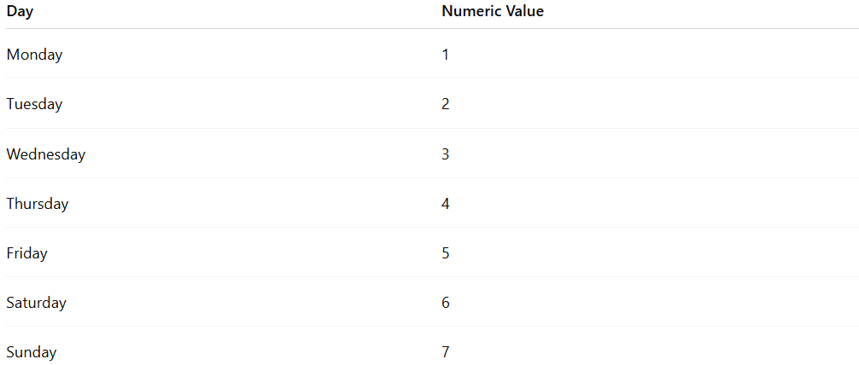
Day | Numeric Value
Monday | 1
Tuesday | 2
Wednesday | 3
Thursday | 4
Friday | 5
Saturday | 6
Sunday | 7
Example dataset:

Order ID | Day_Number
1 | 6
2 | 1
3 | 3

Advantages
# Source: AI Source: Provided by: [Data Path: Persons Table -> ID Column: 1, Name_En Column: Motasem Essam] -> From: [ChatGPT] on [12/10/2025]
- Helps detect weekly patterns
- Useful in sales, traffic, and customer behavior analysis
- Improves predictive model performance

Disadvantages
# Source: AI Source: Provided by: [Data Path: Persons Table -> ID Column: 1, Name_En Column: Motasem Essam] -> From: [ChatGPT] on [12/10/2025]
- May require additional encoding for machine learning models
- Weekly patterns alone may not capture long-term trends

